Template of Abstract for International Symposium
on Surface Science
(Times New Roman, 14pt, bold)

Taro Tsukuba (Underline the presenting author.)^{1*}, Hiroshi Tonegawa², and Sakura Yoshino¹

¹Tsukuba University, 1 Tsukuba, Tsukuba, Ibaraki 300-4352, Japan
²The University of Japan, 1-1-1, Ginza, Tokyo 111-0011, Japan
*e-mail: taro-tsukuba@tukuba-u.ac.jp

An A4-size (210 mm × 297 mm) one-page abstract is required for each presentation, regardless of the type of presentation; invited, oral or poster. It should contain the title of paper, name of author(s), affiliation(s), postal address(es), e-mail address of the corresponding author, and main text. The abstract should be submitted in a PDF format (not larger than 2 MB) with all the used fonts embedded [1]. You can submit your abstract only through the symposium website.
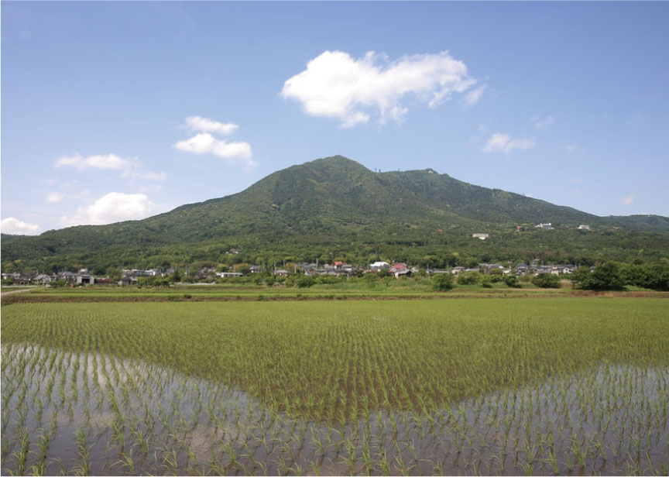
Fig. 1: You can use color figures or photographs as far as the size of the PDF file does not exceed 2MB.
Use 12-point Times New Roman font for the text including author(s)' name, affiliation, references and figures/tables captions. For the title, please use 14-point Times New Roman font in bold.
All the accepted abstracts will be available to the participants through the symposium website. A file containing all the accepted abstracts will also be provided to the participants at the symposium [2].

Fig. 2: Another example of color figure

The deadline for the abstract submission is June 2, 2017.
We encourage all of you to participate the symposium, and we are very much looking forward to welcoming you at Tsukuba soon.

[1] T. Tsukuba and S. Yoshino, J. Tsukuba Sci., 55, 505 (2017).
[2] H. Tonegawa, J. Surf. Sci., 8, 808 (2017).

